
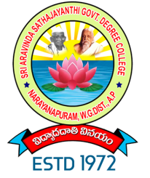
S.A.S. GOVERNMENT DEGREE COLLEGE
NARAYANAPURAM, WEST GODAVARI DISTRICT-534411
(AFFILIATED TO ADIKAVI NANNAYA UNIVERSITY, RAJAMAHENDRAVARAM)
Phone: 08818 252189, E-mail: narayanapuram.jkc@gmail.com

DEPARTMENT OF COMMERCE

EXTENSION ACTIVITY
International Accounting Day
2022-23

Title : International Accounting Day
Date : 15-03-2023
No of Participant : 55

Chief Guest : Principal
Conducted by : Department of Commerce
Topic : Importance of Accounting

Brief Report :
The Department of Commerce is delighted to celebrate the International Accounting Day on March 15, 2023. With 55 participants joining us, including esteemed faculty members, students, from the field, we aim to underscore the significance of accounting in today's global economy.

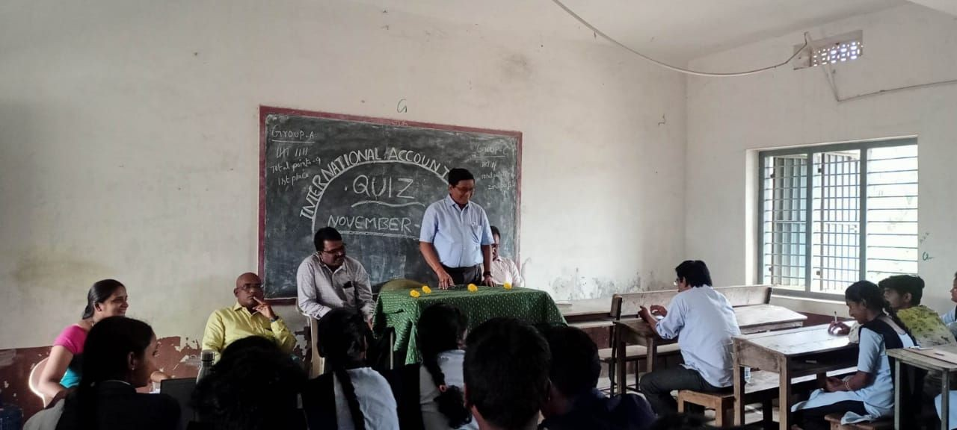
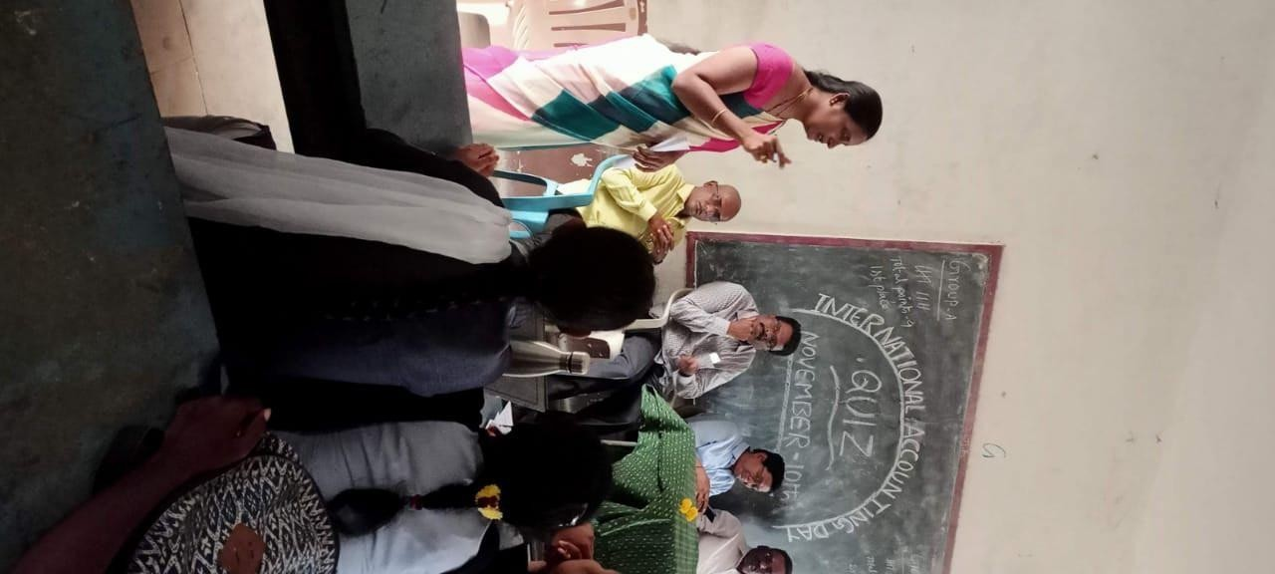

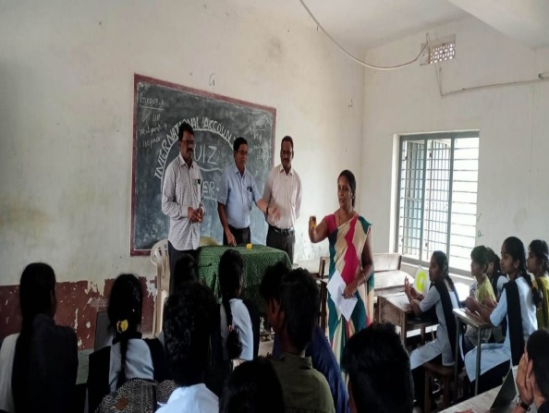
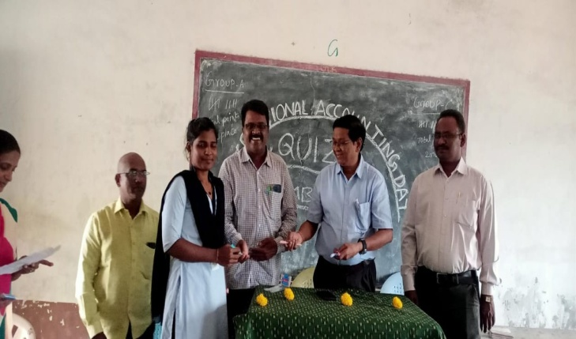
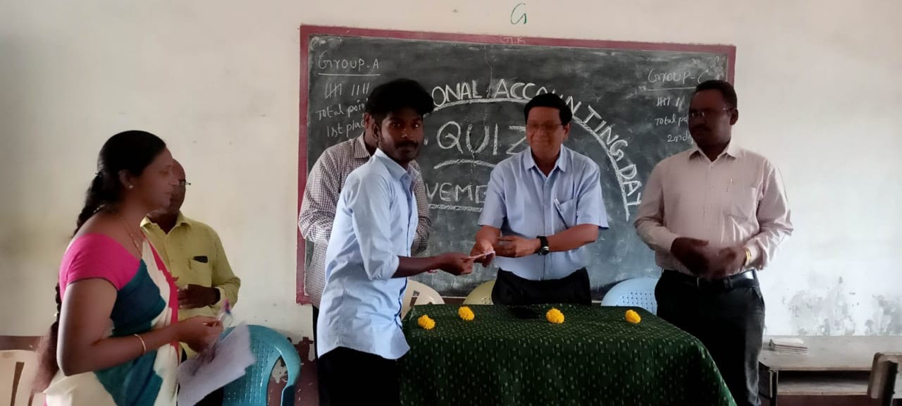

In charge of Department Principal

